Name: John Terry Mbomeh
Senegambia
Banjul
Gambia
Contact: +220-200 4699/271 4750/3854903
Email: jterrymbomeh@gmail.com
What Sapp: +220-200 4699
Employment History:

Duration of my employment  (2018-2019) | Position: Head of Photocopy department  Name of organization: Glory to Glory  Key roles and responsibilities:  - Ensures that all machines are working correctly in order  - Weekly maintenance of machines
Duration of my employment (2018 to 2019) | Position: Logistics and Procurement Officer  Name of organization: God’s Choice Technologies Computer Training Institute  Key roles and responsibilities  - Procuring machines every two (2) weeks per month  - Ensures that all machine are working correctly in order  - Always maintaining the computer lab in order  - Procuring stationary materials/items in whole sales
Duration of my employment (2018 to 2019) | Position: Registrar  Name of organization: God’s Choice Technologies Computer Training Institute  Key roles and responsibilities:  - Taking data base information for each students  - Storing payment records of each student  - Taking information of staff payment  - Establish and maintain a comfortable and inclusive materials for students  - Provide facilitators with regular, scheduled meetings with a designated person, such as a lecture, religious educator, and student president, to evaluate how the institution is going and to continue developing facilitation skills.
Duration of my employment (2018 to 2019) | Position: Finical Secretary Officer  Name of organization: Rogbangba Progressive Youth Organization  Key roles and responsibilities  - Taking care of monetary issue  - Ensures that to put things in place for any monetary programs
Duration of my employment (2018 to 2019) | Position: Marketing Officer  Name of organization: God’s Choice Technologies Computer Training Institute  Key roles and responsibilities:  - Going out and talk to customers how they can reach to the institute  - Having house to house campaign telling every good aspect about the institution
Duration of my employment (2019 to 2020 | Position: ADMIN  Name of organization: God`s Choice Technologies Computer Training Institute  Key roles and responsibilities:  - To ensures that all student`s fees are to be collected before or during the examination progress.  - To put all student’s affairs in place  - Working as the assistance principal in the organization/school etc.
Duration of my employment (2020 to 2021 | Position: Desktop Publisher  Name of organization: Modern Technology Computer Training Institute  Key roles and responsibilities:  - To give/delivery the best satisfaction to customers  - To design, prepared and print documents
Duration of my employment (2020 to 2021 | Position: ICT Lecturer  Name of organization: Modern Technology Computer Training Institute  Key roles and responsibilities:  - To give/delivery the best satisfaction to student  - To ensure that student will go out with the best quality in term of ICT
Duration of my employment (2022 to 2023) | Position: Class Room Teacher  Name of organization: Leaders Academy School  Key roles and responsibilities:  - To give/delivery the best satisfaction to pupils  - To ensure that pupils should understand 85-95% of what the teacher has though before leaving the classroom  - Passing information to pupils during classes most be skillful and should be well understood by the pupils

Educational Background:

- 2014-2015
- Natural Keyboard Entertainment School

Certificate in piano (key-board)
- 2018-2019
- Certificate of best student of the year

2018-2019
- God`s Choice Technology Computer Training School

Certificate in Microsoft package
- Statement of Result

- 2019-2020
- Certificate in Graphics Design

- 2019-2020
- Certificate in Microsoft Package Teaching Course

- 2019-2020
- Certificate in Computer Hardware Course

- 2020-2021
- Diploma in Microsoft package

Other Professional Experiences
Photography
Video editor
Piano playing
Social media marketing etc.

Referees:
Name: Mr. Ishmael Turay
Organization: God’s Choice Technologies Computer Institute
Position: Lecturer
Contact: +23288-570-924
Name: Abdulai Tunkara
Organization: Modern Technology Computer Training Institute
Position: Chief Executive Officer C.E.O
Contact: +232-874-524


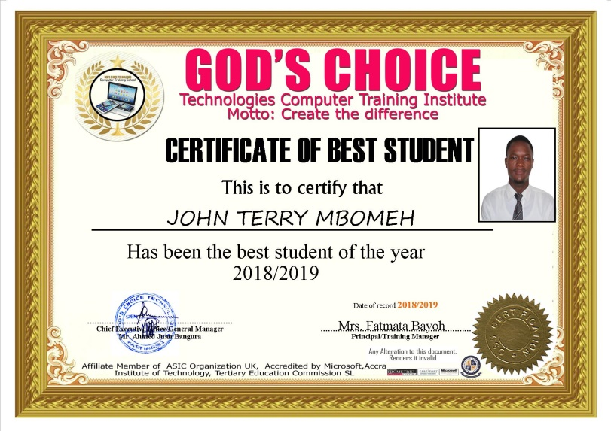
Below Are Some of My Relevant Documents

